1. The `git add` command stages changes in the working directory for the next commit. It tells Git to include updates to a particular file or files in the next commit.

2. The command to create a branch named “feature-login” is `git branch feature-login`.

3. A pull request is a way to propose changes to a repository and have them reviewed before merging. To create a pull request:

1. Push your branch to the remote repository.

2. Navigate to the repository on GitHub.

3. Click the "Pull requests" tab and then "New pull request".

4. Select the branch you want to merge and submit the pull request.

4. To add collaborators, go to the repository on GitHub, click "Settings", then "Collaborators & teams", and invite the collaborator by their GitHub username or email.

5. The command to commit changes in a GitHub repository is `git commit -m "Your commit message"`.

6. **Done**

7. **Done**

**8.** 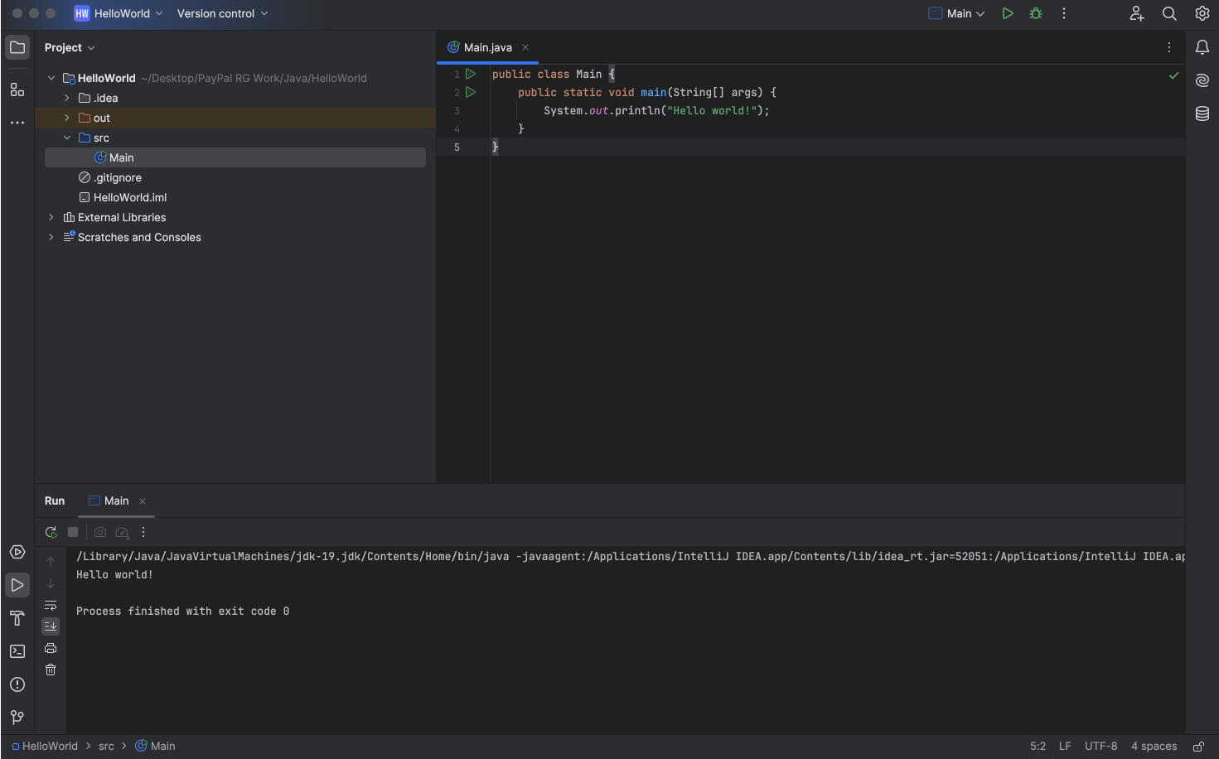

**9.** A. Ctrl + R by pointing the cursor at the start of the line and no text is selected before.  
 B. Ctrl + C by pointing the cursor at the start of the line and no text is selected before.

C. To comment/uncomment a line: Cmd + / (macOS)

D. To delete a line: Cmd + Backspace (macOS)